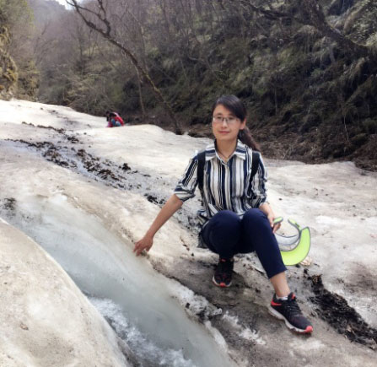
【姓 名】杨玉英
【职称职务】副教授
【学科专业】物理化学
【个人简介】
1998-2002年在西北师范大学化学化工学院攻读理学学士学位，2005获得硕士学位并于同年7月留校从事物理化学教学和科研工作，2013年获博士学位。2010、2011年度西北师范大学教学质量优秀教师奖，2012年校青年教师教学技能大赛第五名，2014年西北师范大学“青年教师教学科研之星资助计划”
【教育及科研成果】
1.研究领域
主要从事电化学相关新能源材料的制备及应用研究。先后参与国家自然科学基金资助项目3项，教育部博士点基金资助项目一项，甘肃省自然科学基金重点资助项目一项，主持完成西北师范大学青年教师科研能力提升计划项目一项，并在国内外学术刊物上发表论文20余篇。
2.教育工作
主讲过的课程主要有：《物理化学》、《化工热力学》、《文献检索》、《理化测试》、《基础实验》
3.代表性论文
[1] Yi Zhou, Yuying Yang*, Ruijing Wang, Xiaotong Wang, Xinyuan Zhang, Lulu Qiang, Wenbin Wang, Qian Wang，Zhongai Hu. Rhombic porous CoP₂nanowire arrays synthesized by alkaline etching as highly active hydrogenevolution-reaction electrocatalysts,J. Mater. Chem. A,2018, 6, 19038-19046.
[2] Yuying Yang*, Yi Zhou, Zhongai Hu, Wenbin Wang, Xinyuan Zhang, Lulu Qiang, Qian Wang. 3D thin-wall cell structure nickel-cobalt-molybdenum ternary phosphides on carbon cloth as high-performance electrodes for asymmetric supercapacitors,Journal of Alloys and Compounds,2019, 772, 683-692.
[3] Yuying Yang*, Yi Zhou, Yufeng An, Quancai Zhang, Xiaotong Wang, Xia Yang, Zhongai Hu. Battery-supercapacitor hybrid device based on agarics-derived porous nitrogen-doped carbon and 3D branched nanoarchitectures CNTs/Ni(OH)₂,Journal of Physics and Chemistry of Solids, 2018, 119, 126-137.
[4] Yufeng An, Yuying Yang, Zhongai Hu, Bingshu Guo, Xiaotong Wang, Xia Yang, Quancai Zhang, Hongying Wu High-performance symmetric supercapacitors based on carbon nanosheets framework with graphene hydrogel architecture derived from cellulose acetate.Journal of Power Sources, 2017,337, 45-53.
[5] Bingshu Guo，Yuying Yang，Zhongai Hu，Yufeng An，Quancai Zhang，Xia Yang，Xiaotong Wang，Hongying Wu. Redox-active organic molecules functionalized nitrogen-doped porous carbon derived from metal-organic framework as electrode materials for supercapacitor.Electrochimica Acta, 2017, 223, 74–84
[6] Xia Yang, Yuying Yang,* Quancai Zhang, Xiaotong Wang, Yufeng An, Bingshu Guo,Zhongai Hu* , Hongying Wu. Dissected carbon nanotubes functionalized by 1-hydroxyanthraquinone for high-performance asymmetric supercapacitors,RSC Adv.,2017, 7, 48341-48353.
[7]Xiaotong Wang, Yuying Yang,* Quancai Zhang, Xia Yang, and Zhongai Hu*.Lamellar Oxygen-Enriched Graphene Hydrogel with Linking-up Network Porous Structure for High-Performance Supercapacitors,J. Phys. Chem. C2018, 122, 6526-6538.
[8]Quancai Zhang, Zhongai Hu*, Yuying Yang**, Ziyu Zhang, Xiaotong Wang, Xia Yang, Yufeng An, Bingshu Guo. Metal organic frameworks-derived porous carbons/ruthenium oxide composite and its application in supercapacitor,Journal of Alloys and Compounds,2018, 735, 1673-1681.
[9]Yuying Yang, Yarong Liang, Ziyu Zhang, Yadi Zhang, Hongying Wu, Zhongai Hu. Morphology Well-Controlled Synthesis of NiO by Solvothermal Reaction Time and their Morphology-Dependent Pseudocapacitive Performances.Journal of Alloys and Compounds,2016, 658, 621-628.
[10]Yuying Yang, Yarong Liang, Yadi Zhang, Ziyu Zhang, Zhiming Li and Zhongai Hu. Three-dimensional graphene hydrogel supported ultrafine RuO₂nanoparticles for supercapacitor electrodes.New Journal of Chemistry,2015,39,4035-4040.

