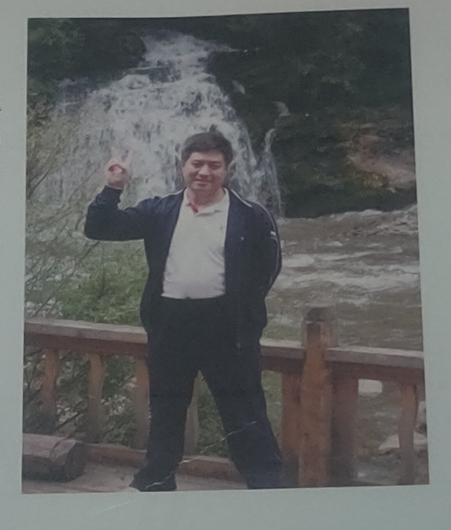
【姓名】张彰
【职称职务】副教授、硕士生导师
【个人简历】
1996年获西北师范大学学士学位，2005年获西北师范大学硕士学位，2009年获西北师范大学博士学位。
【研究方向】
主要从事液相合成、绿色合成等领域的研究工作，先后参研国家自然科学基金资助项目3项。发表SCI收录论文31篇。获甘肃省级自然科学三等奖1项、甘肃省高校科技进步奖3项。
【科研项目】
参研国家自然科学基金（20902073）、国家自然科学基金（21062017）、甘肃省级自然科学基金（096RJZA116）、甘肃省级自然科学基金（3ZS061-A25-019）；主持青年教师科研能力提升计划骨干项目（NWNU-LKQN-10-15）。
【主讲课程】
《有机合成化学》、《有机化学》
【主要论文】
1)Xicun Wang, Zhang Zhang and Zheng Li. Grinding Synthesis of 1-Aryloxyacety l-4-(2-Benzofurancarbonyl)-Semicarbazides and Their Plant-Growth Regulating Activity. Journal of Northwest Normal University. 2004, 40(3), 136-137;

2)Xicun Wang, Zhang Zhang and Zheng Li. Synthesis of 2-aryl-5-[5′-(4″- chlorophenyl)-2′-furyl]-1,3,4-oxadiazoles under microwave irradiation. Journal of Northwest Normal University. 2004, (40)4, 49-51.

3)Zhang Zhang, Xicun Wang and Zheng Li. An Expedious Room-Temperature Grinding Method to 5-Aryl-2-Furoyl Substituted Thioureas and Thiosemicarbazides. Synth. Commun. 2004, 34(8), 1407- 1414;

4)Xicun Wang, Zhengjun Quan, Fang Wang, Mangang Wang,Zhang Zhang, and Zheng Li. PEG-SO3H as Catalyst for 3,4-Dihydropyrimidones via Biginelli Reaction Under Microwave and Solvent-Free Conditions. Synthetic Communications. 2006, 36, 451–456.

5)Zhengjun Quan,Zhang Zhang,Xicun Wang,Zheng Li. Efficient Synthesis and Plant-Growth Regulating Activities of 1-Aryloxyacetyl-4-(2-benzofuroyl)- semicarbazides. Phosphorus Sulfur and Silicon. 2006, 181, 1397–1402.

6)Xicun Wang, Zhengjun Quan, Jun-Ke Wang, Zhang Zhang and Mangang Wang. A practical and green approach toward synthesis of N3-substituted dihydropyrimidinones: Using Aza-Michael addition reaction catalyzed by KF/Al2O3. Bioorganic and medicinal Chemistry Letters. 2006, 16 ,4592–4595.

7)Xicun Wang, Fang Wang, Zhengjun Quan, Zhang Zhang, and Mangang Wang. One-Pot Synthesis of 2-Acylimino-3-arylthiazoline Derivatives in Aqueous Media. Synthetic Communicationsw. 2006, 36, 2453–2460.

8)Xi Cun Wang, Fang Wang, Zheng Jun Quan, Zhang Zhang, and Man Gang Wang. One-pot Synthesis of 2-Acylimino-3-aryl-1,3-thiazoline Derivatives in Aqueous Media. J. Heterocyclic Chem, 43, 1 (2006).

9)Xicun Wang, Zhang Zhang, Zhengjun Quan, Mangang Wang, Fang Wang, and Zheng Li. Expeditious One-Step Method to 5-Aryl-2- furoyl Substituted Thioureas and Thiosemicarbazides in Aqueous Media. Synthetic Communications. 2006, 36, 843–847.

10)王喜存 张彰 权正军 王满刚 王 芳 李 政 杨春燕. 水介质中N-芳基-N'-(2-苯并呋喃甲酰基)硫脲及1-芳甲酰基-4- (2'-苯并呋喃甲酰基)氨基硫脲的合成. 中国有机化学. 2006, 26(7), 967～970.

11)Xicun Wang,Zhengjun Quan and Zhang Zhang. Michael additions of dihydropyrimidines and 2-amino-1,3,4-thiadiazoles to a,b-ethylenic compounds:using polyethylene glycols as a green reaction media. Tetrahedron. 2007, 63, 8227–8233.

12)Xi-Cun Wang, Zheng-Jun Quan, Zhang Zhang, Ya-Juan Liu, and Peng-Yan Ji. Efficient Synthesis of 5H-Thiazolo[3,2-a] pyrimidines from Reactions of 3,4-Dihydropyrimidine-thiones with α-Bromoacetone in Aqueous Media. Letters in Organic Chemistry. 2007, 4, 370-373

13)Xicun Wang, Aiying Song, Jihua Zhu, Zhi Yang, and Zhang Zhang. Hydrogen Peroxide–Promoted Transformation of Thioureas/Thiosemicarbazides to Related Ureas/Semicarbazides at Room Temperature via Grinding. Synthetic Communications. 2007, 37, 1627–1633.

14)Zheng-Jun Quan, Zhang Zhang, Jun-Ke Wang, Xi-Cun Wang, Ya-Juan Liu, and Peng-Yan Ji. Efficient Synthesis of 5H-Thiazolo[3,2-a] pyrimidines from Reactions of 3,4-Dihydropyrimidine-thiones with α-Bromoacetone in Aqueous Media. Heteroatom Chemistry. 2008, 19 ,149-153.

15)Wang, Xi-Cun*, Quan, Zheng-Jun, Zhang, Zhang. An Environmentally Benign Access to Dimethylated 3,4-Dihydropyrimidines Using Dimethyl Carbonate as Methylating Agent under Microwave. Chinese Journal of Chemistry. 2008, 26, 1~10.

16)Wang, Xi-Cun*, Quan, Zheng-Jun, Zhang, Zhang. An Environmentally Benign Access to Dimethylated 1,6-Dihydropyrimidines Using Dimethyl Carbonate as Methylating Agent under Microwave. Chinese Journal of Chemistry. 2008, 26, 368~372.

17)Zheng-Jun Quan, Yu-Xia Da, Zhang Zhang, Xi-Cun Wang, PS–PEG–SO3H as an efficient catalyst for 3,4-dihydropyrimidones via Biginelli reaction. Catalysis Communications. 2009, 10, 1146–1148

18)Yu-Xia Da, Zhi Yang, Zheng-Jun Quan, Zhang Zhang, and Xi-Cun Wang. Utilization of 2-Benzo[b]furan Carboxylic Acid Hydrazide in the Synthesis of 1,3,4-Oxadiazole Derivatives. J. Heterocyclic Chem, 2009, 46, 737-741.

19)Wang xi-cun, Wang Fang, Quan Zheng-Jun, Zhang Zhang. Synthesis and X-ray Structural Studies of 2-(2-Benzofuroylimino)-3-aryl-4-phenyl-1,3-thiazolines. Chinese J. Struct. Chem. 2009, 28, 957~962.

20)权正军 张彰 达玉霞 王喜存. Biginelli 3,4-二氢嘧啶-2-酮衍生物的合成研究新进展. 中国有机化学. 2009, 29, 876～883.

21) 王喜存 许新兵 权正军 张彰. PEG-400为绿色反应介质无催化一锅法合成 2-氨基-3-氰基-4-芳基-4H-苯并色烯衍生物. 中国有机化学. 2009, 29,1821～1824.

22) Zheng-Jun Quan, Rong-Guo Ren, Yu-Xia Da, Zhang Zhang, Xiao-Dong Jia, Cai-Xia Yang and Xi-Cun Wang. One-pot two-step synthesis of N3-functionalized 3,4-dihydropyrimidinones in the presence of TMSCl. Heterocycles, 2010. 81, 1827-1841.

23)Zheng-Jun Quan, Rong-Guo Ren, Xiao-Dong Jia, Yu-Xia Da, Zhang Zhang, Xi-Cun Wang. N-Alkoxymethylation of heterocyclic compounds with diethyl phosphite via cleavage of P-O bond, Tetrahedron. 2011, 67, 2462-2467;

24)Xi-CunWang, Guo-Jun Yang, Xiao-Dong Jia, Zhang Zhang, Yu-Xia Da, Zheng-Jun Quan. Synthesis of C2-functionalized pyrimidines from 3,4-dihydro pyrimidin-2(1H)-ones by the Mitsunobu coupling reaction, Tetrahedron. 2011, 67, 3267-3272;

25)Zheng-Jun Quan, Rong-Guo Ren, Yu-Xia Da, Zhang Zhang and Xi-Cun Wang. Efficient and Convenient Synthesis of N3-(Acyloxymethyl) dihydropyrimidinones by a One-Pot Two-Step Method. Letters in Organic Chemistry, 2011, 8, 188-192;

26)Zheng-Jun Quan, Rong-Guo Ren, Yu-Xia Da, Zhang Zhang,and Xi-Cun Wang. Alkylation of SH-Heterocycles with Diethyl Phosphite Using Tetrachloroethylene as an Efficient Solvent. Heteroatom Chemistry, 2011, 22(5), 653-658;

27)ZhengJun Quan,Rong-Guo Ren,Yu-Xia Da,Zhang Zhang,and Xi-Cun Wang. Glycerol as an alternative green reaction Medium for multicomponent reactions using Ps-PEG-OSO3H as catalyst, Synthetic Communications, 2011, 41,1–11;

28)Xi-Cun Wang, Zhong-Jie Wang, Zhang Zhanga, and Zheng-Jun Quana. KF/Al2O3 promoted aza-Michael addition of 4-aryl-7,7-dimethyloctahy droquinazolinones to α,β-ethylenic compounds, Journal of chemical research, 2011, 460–464;

29)Yu Xia Da, Zhang Zhang, Zheng Jun Quan. Intermolecular cyclocondensation reaction of 3,4-dihydropyrimidine-2-thione under the Mitsunobu reaction conditions, Chinese Chemical Letters, 2011, 22, 679–682;

30)Xi-Cun Wang, Ying Wei, Yu-Xia Da, Zhang Zhang and Zheng-Jun Quan. One-step synthesis of tetrazolo[1,5-a]pyrimidines by cyclization reaction of dihydropyrimidine-2-thiones with sodium azide, Heterocycles, 2011,83(12), 2811-2822;

31)Xi-Cun Wang,* Xue-Hong Tang, Yu-Xia Da, Zhang Zhang and Zheng-Jun Quan. Ethyl 6-methyl-3-(2-methylprop-1-enyl)-2-oxo-4-phenyl-1,2,3,4-tetrahydropyrimidine-5-carboxylate Acta Crystallographica Section E. 2011, E67, o2993;

